SIMATS ENGINEERING
ASSESSMENT TOOL 2

COURSE NAME: MLA03
COURSE CODE: Reinforcement learning for Environment and Agent
NAME: R. Rupa Sree
REGISTER NUMBER: 192472122

COURSE OUTCOME COVERED

CO2: Apply Dynamic Programming methods to solve reinforcement learning problems and derive optimal policies for decision-making tasks. ( BL2, BL3)

Assessment Tool Weightage: 30%

Dr G.A. SENTHIL

QUESTIONS: 10 Total Marks: 50

Annexure A
Application - Based Questions

- Design and develop a Reinforcement Learning framework a ride-sharing company uses Reinforcement Learning to match drivers with passengers efficiently. Apply RL concepts to define the state space, action space, and reward function to minimize waiting time and improve service quality.
Ans:

Objective-
The objective is to develop an intelligent ride-sharing system that efficiently matches drivers with passengers, minimizes waiting time, reduces travel distance, and improves customer satisfaction.

Why Reinforcement Learning?
Reinforcement Learning is suitable because it learns from previous ride requests and continuously improves driver-passenger matching decisions. It adapts to changing traffic conditions, passenger demand, and driver availability without requiring predefined rules.
Agent & Environment
Agent:
- Ride-Sharing Matching System
Environment:
- Drivers
- Passengers
- Traffic conditions
- GPS locations
- Ride requests

State Space
The state represents the current condition of the ride-sharing system.
Examples:
- Driver location
- Passenger location
- Driver availability
- Traffic conditions
- Distance between driver and passenger

Action Space
The RL agent can perform the following actions:
- Assign the nearest driver
- Reassign another nearby driver
- Reject the request
- Delay assignment
- Offer a shared ride

Reward Function
Positive Rewards (+)
- Quick passenger pickup (+100)
- Short travel distance (+60)
- Successful ride completion (+120)
- High customer rating (+80)
Negative Rewards (−)
- Long waiting time (−80)
- Driver cancellation (−100)
- Incorrect driver assignment (−60)
- Customer complaint (−70)

Policy
The policy helps the RL agent choose the best available driver based on the current state. It selects the driver who can reach the passenger quickly while minimizing travel time and improving service quality.

Learning Process
- Observe the current system state.
- Receive a passenger request.
- Select the best available driver.
- Complete the ride.
- Receive reward or penalty.
- Update the policy.
- Repeat for future requests.

RL Architecture
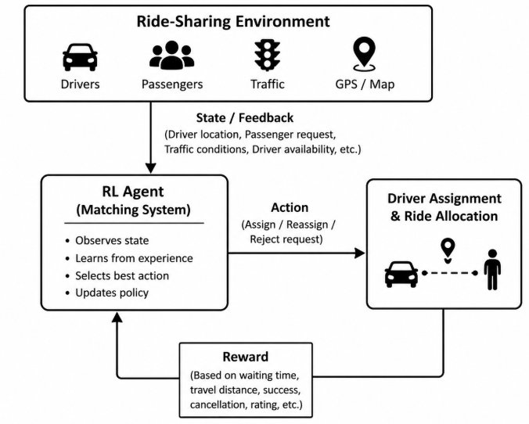
Expected Outcomes
- Reduced passenger waiting time
- Better driver utilization
- Faster ride allocation
- Improved customer satisfaction
- Efficient use of transportation resources

Conclusion
Reinforcement Learning enables the ride-sharing system to continuously improve driver-passenger matching through experience. As the system learns from each ride, it provides faster pickups, better driver utilization, improved service quality, and higher customer satisfaction.

- An e-learning platform uses Reinforcement Learning to recommend personalized study materials. Recall how exploration and exploitation strategies help balance familiar and new content recommendations.
Ans:
Objective
The objective is to provide personalized learning materials that improve student understanding, engagement, and academic performance based on individual learning behavior.

Why Reinforcement Learning?
Reinforcement Learning is suitable because it learns from student interactions and continuously improves content recommendations. It balances recommending familiar topics with introducing new topics to enhance learning.

Agent & Environment
Agent:
- Recommendation System
Environment:
- Students
- Learning platform
- Courses
- Quizzes
- Learning history

State Space
The state represents the student's current learning status.
Examples:
- Student progress
- Quiz scores
- Completed lessons
- Learning history
- Time spent learning

Action Space
The RL agent can:
- Recommend familiar content
- Recommend new content
- Suggest quizzes
- Recommend revision materials
- Unlock the next lesson

Reward Function
Positive Rewards (+)
- High quiz score (+100)
- Course completion (+80)
- Increased engagement (+60)
- Positive feedback (+50)

Negative Rewards (−)
- Low quiz score (−80)
- Skipped lessons (−50)
- Low engagement (−60)
- Course dropout (−100)

Policy
The policy selects learning materials based on the student's current performance and learning needs to maximize learning outcomes.

Learning Process
- Observe student progress.
- Recommend learning material.
- Student interacts with the content.
- Receive reward or penalty.
- Update recommendation policy.
- Repeat for future sessions.

RL Architecture
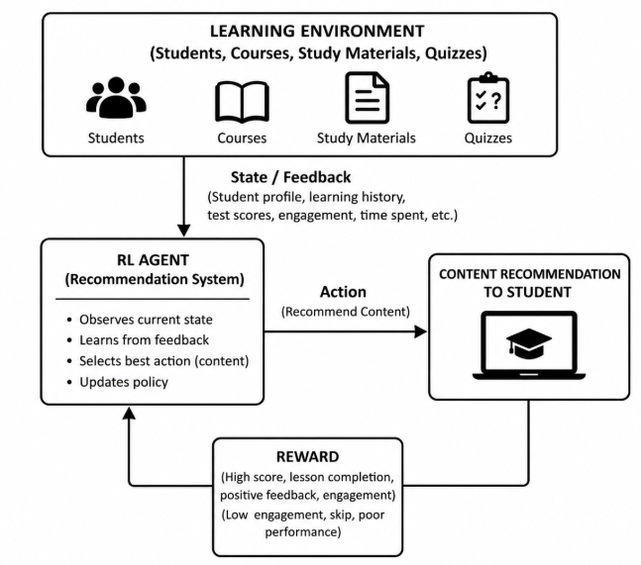
Expected Outcomes
- Personalized learning
- Better student engagement
- Higher completion rates
- Improved academic performance
- Continuous adaptation to student needs

Conclusion
Reinforcement Learning enables an e-learning platform to continuously improve personalized recommendations by learning from student interactions. This results in better engagement, improved learning outcomes, and enhanced educational experiences.

- Design and develop a Reinforcement Learning framework a robotic vacuum cleaner uses Reinforcement Learning to clean efficiently while avoiding obstacles. Apply the concept of policy and explain how the value function improves performance over time.
Ans:
Objective
The objective is to develop an intelligent robotic vacuum cleaner that cleans the maximum area efficiently while avoiding obstacles and conserving battery power.

Why Reinforcement Learning?
Reinforcement Learning allows the robot to learn the most efficient cleaning paths through experience instead of following fixed routes.

Agent & Environment
Agent:
- Robotic Vacuum Cleaner
Environment:
- Rooms
- Furniture
- Obstacles
- Charging station

State Space
Examples:
- Robot location
- Battery level
- Dirt location
- Obstacle position
- Charging station location

Action Space
The RL agent can:
- Move forward
- Turn left
- Turn right
- Clean surface
- Return to charging station

Reward Function
Positive Rewards (+)
- Clean area (+100)
- Avoid obstacle (+50)
- Save battery (+40)
- Complete cleaning (+120)
Negative Rewards (−)
- Collision (−100)
- Battery drain (−50)
- Missed dirty area (−40)

Policy
The policy selects the safest and shortest path to maximize cleaning efficiency while minimizing energy consumption.

Learning Process
- Observe surroundings.
- Select movement.
- Clean area.
- Receive reward.
- Update policy.
- Continue cleaning.

RL Architecture
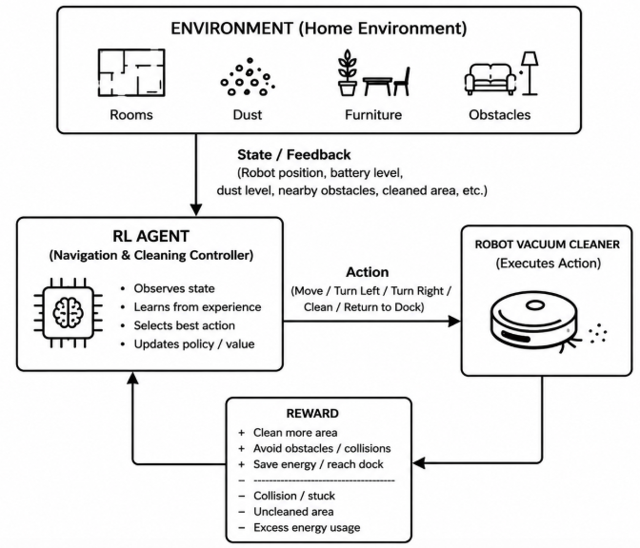

Expected Outcomes
- Faster cleaning
- Better navigation
- Reduced battery usage
- Efficient obstacle avoidance
- Improved cleaning performance

Conclusion
Reinforcement Learning enables robotic vacuum cleaners to learn efficient cleaning strategies through continuous interaction with the environment, improving navigation, energy efficiency, and cleaning performance.

- Design a model drone delivery system uses Reinforcement Learning for navigation. Recall how exploration and exploitation strategies influence route optimization.
Ans:
Objective
The objective is to optimize drone delivery routes to ensure fast, safe, and energy-efficient package delivery.

Why Reinforcement Learning?
Reinforcement Learning helps drones learn optimal delivery routes based on traffic, weather, battery level, and obstacles while continuously improving delivery performance.

Agent & Environment
Agent:
- Delivery Drone
Environment:
- GPS locations
- Weather conditions
- Buildings
- Obstacles
- Delivery requests

State Space
Examples:
- Drone location
- Battery level
- Weather condition
- Destination
- Obstacle location

Action Space
The RL agent can:
- Move forward
- Change route
- Ascend
- Descend
- Land
- Return to base

Reward Function
Positive Rewards (+)
- Fast delivery (+120)
- Safe navigation (+80)
- Battery saving (+60)
- Successful delivery (+100)
Negative Rewards (−)
- Delivery delay (−80)
- Collision (−120)
- High energy consumption (−60)
- Wrong route (−70)
Policy
The policy selects the safest and shortest delivery route while minimizing delivery time and energy consumption.

Learning Process
- Observe current environment.
- Select route.
- Deliver package.
- Receive reward.
- Update policy.
- Repeat deliveries.

RL Architecture
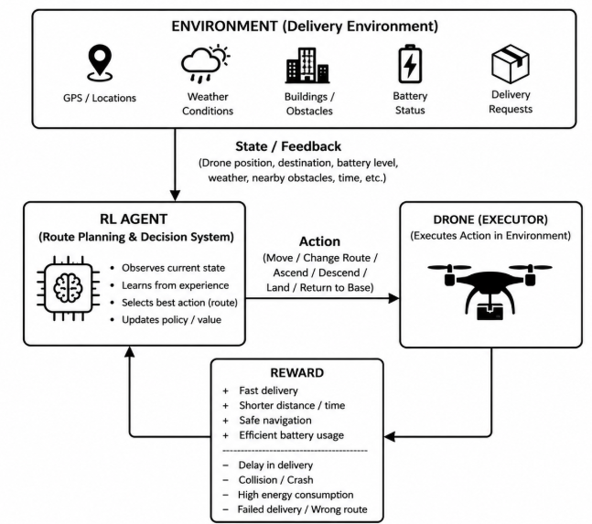
Expected Outcomes
- Faster deliveries
- Reduced energy usage
- Safe navigation
- Better route optimization
- Higher customer satisfaction

Conclusion
Reinforcement Learning enables drones to continuously improve delivery routes by learning from experience, resulting in faster, safer, and more efficient package delivery.

- A smart irrigation system uses Reinforcement Learning to optimize water usage. Create an RL framework by defining states, actions, and reward function.
Ans:
Objective
The objective is to optimize irrigation by supplying the right amount of water at the right time while conserving water and improving crop yield.

Why Reinforcement Learning?
Reinforcement Learning learns irrigation schedules based on soil moisture, weather, and crop conditions, enabling efficient water management.

Agent & Environment
Agent:
- Irrigation Controller
Environment:
- Soil
- Crops
- Weather
- Water resources

State Space
Examples:
- Soil moisture
- Temperature
- Rainfall
- Crop growth stage
- Water level

Action Space
The RL agent can:
- Start irrigation
- Stop irrigation
- Increase water flow
- Reduce water flow
- Delay irrigation

Reward Function
Positive Rewards (+)
- Healthy crops (+100)
- Water conservation (+80)
- Higher crop yield (+120)
- Efficient irrigation (+60)
Negative Rewards (−)
- Overwatering (−80)
- Underwatering (−90)
- Water wastage (−70)
- Crop stress (−100)

Policy
The policy decides when and how much water should be supplied based on the current soil and weather conditions.

Learning Process
- Observe soil and weather conditions.
- Decide irrigation action.
- Monitor crop response.
- Receive reward or penalty.
- Update policy.
- Continue learning.

RL Architecture
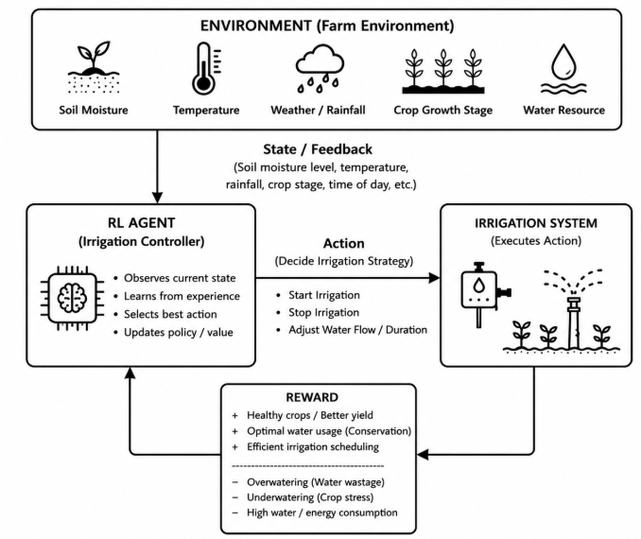
Expected Outcomes
- Water conservation
- Improved crop yield
- Reduced irrigation cost
- Better resource utilization
- Sustainable farming

Conclusion
Reinforcement Learning enables smart irrigation systems to continuously optimize watering decisions based on environmental conditions, leading to healthier crops, efficient water usage, and improved agricultural productivity.

Code of Conduct:

I R. Rupa Sree (192472122) (Name / Reg No) certify that this submission is my original work and that I have adhered to the guidelines specified for this assessment.
I understand that any violation of academic integrity rules will result in disciplinary action.

Signature of the student:
R. Rupa Sree

RUBRICS FOR CALCULATION

Criteria | Weightage | Level 4 – Exemplary | Level 3 – Proficient | Level 2 – Developing | Level 1 – Beginning
Understanding of Problem Context | 20 | Clearly understands the problem and accurately identifies all requirements | Good understanding with minor gaps | Basic understanding; some requirements unclear | Poor understanding or misinterpretation of the problem
Application of Concepts | 30 | Accurately applies appropriate concepts to solve complex problems | Applies relevant concepts correctly with minor errors | Applies basic concepts with limited accuracy | Fails to apply appropriate concepts
Problem-Solving Approach | 20 | Logical, well-structured, and efficient approach | Mostly logical approach with minor gaps | Basic approach with some inconsistencies | Illogical or unclear approach
Accuracy of Solution | 20 | Completely correct solution with proper justification | Mostly correct with minor errors | Partially correct solution | Incorrect or incomplete solution
Clarity | 10 | Clear, well-organized, and properly explained solution | Understandable with minor clarity issues | Limited clarity and explanation | Poorly presented and difficult to understand

